**GOOGLE RE-CAPTCHA IMAGE CLASSIFICATION**

**ABSTRACT:**

This project aims to build an advanced classification system for Google reCAPTCHA images using a combination of deep learning and machine learning techniques. The primary goal is to create an intelligent and accurate model capable of distinguishing between reCAPTCHA images containing text and those without text.

The process involves preprocessing the reCAPTCHA images to enhance their quality and remove irrelevant elements. Convolutional neural networks (CNNs) and traditional machine learning algorithms, such as Support Vector Machines (SVM) and Random Forests, are combined in a hybrid model to classify the preprocessed images. The CNN architecture consists of multiple convolutional layers, pooling layers, and fully connected layers, culminating in a softmax activation function for the final classification.

The hybrid model's performance is evaluated using metrics such as accuracy, precision, recall, and F1-score, demonstrating its effectiveness in classifying reCAPTCHA images across various image variations. This project has practical implications in automating reCAPTCHA solving, improving accessibility for users with disabilities, and enhancing the overall security and usability of web applications. By leveraging deep learning and machine learning techniques, the project contributes to advancing image classification technologies and strengthening defenses against online threats and abuse.

**INTRODUCTION:**

In this project, we focus on the classification of Google reCAPTCHA images, which are used to protect websites from fraud and abuse without creating friction for legitimate users. reCAPTCHA employs an advanced risk analysis engine and adaptive challenges to distinguish between human users and automated bots. By analyzing reCAPTCHA images, we can identify patterns and features that help distinguish between text-containing and text-free images.

Our goal is to develop a machine learning model capable of accurately classifying reCAPTCHA images. We will use a deep learning-based approach, specifically a convolutional neural network (CNN), to process and classify the images.

The performance of the model will be evaluated using metrics such as accuracy, precision, recall, and F1-score. We expect the model to achieve high accuracy in classifying reCAPTCHA images, demonstrating the effectiveness of deep learning techniques in image classification tasks.

This project has potential applications in automating reCAPTCHA solving, improving accessibility, and understanding the limitations of CAPTCHA systems. By accurately classifying reCAPTCHA images, we can develop more robust and user-friendly systems to protect websites from fraud and abuse.

**PROBLEM STATEMENT:**

The current implementation of Google reCAPTCHA, while effective in preventing spam bots, presents challenges for users, particularly those with visual impairments or learning difficulties. The image-based puzzles used in reCAPTCHA can sometimes be difficult to solve or ambiguous, leading to frustration and accessibility issues.

The problem lies in the need for a more user-friendly and inclusive solution that maintains security while minimizing inconvenience for legitimate users. This entails developing an advanced image recognition system capable of accurately solving reCAPTCHA challenges with high precision and efficiency.

The challenge is to create a program that can reliably identify and classify various objects within reCAPTCHA images, such as cars, traffic lights, crosswalks, and storefronts. This program must undergo rigorous testing and refinement to ensure its accuracy and reliability across a wide range of scenarios.

**OBJECTIVES:**

**Gathering Images:** We'll start by collecting a diverse set of images resembling those used in reCAPTCHA challenges. These images will include various objects like cars, buses, storefronts, and more.

**Image Cleanup**: Next, we'll ensure that our image dataset is clean and clear. We'll address any issues such as blurriness, distortion, or inconsistent lighting to improve the program's ability to recognize objects accurately.

**Training the Program:** Using advanced machine learning techniques, we'll train our computer program to recognize different objects within the images. Through repetition and feedback, the program will learn to identify common patterns and features associated with each object.

**Testing and Refinement:** Following the training phase, we'll rigorously test the program's accuracy and effectiveness. We'll analyze its performance and identify any areas where it may struggle or make mistakes. Based on these findings, we'll refine the program to improve its overall performance.

**Integration with reCAPTCHA**: Once our program demonstrates a high level of accuracy and reliability, we'll integrate it with the Google reCAPTCHA system. This integration will enable our program to assist users in solving image-based puzzles quickly and seamlessly.

**Accessibility Features:** We'll ensure that our enhanced reCAPTCHA solution is accessible to all users, including those with disabilities. This may involve implementing features such as audio instructions, customizable interfaces, and alternative input methods to accommodate diverse user needs.

**ARCHITECTURE:**

* **Frontend Interface**: A user-friendly interface designed to facilitate seamless interaction with the reCAPTCHA system. This interface should prioritize accessibility features to ensure usability for all users, including those with disabilities.
* **Backend System**: The core of the system will consist of an image recognition module powered by machine learning algorithms. This module will be responsible for analyzing and interpreting the images presented in the reCAPTCHA challenges.
* **Integration with Google reCAPTCHA API**: Seamless integration with the existing Google reCAPTCHA API will enable the system to retrieve challenges and validate user responses. This integration will ensure compatibility with existing web applications that utilize the reCAPTCHA system for security.

**REQUIREMENT SPECIFICATIONS:**

* **Functional**: Accurate image recognition, accessibility features, decision engine, API integration.
* **Non-functional:** Performance, accuracy, security, scalability.
* **Usability**: Intuitive interface, accessibility.
* **Ethical and Legal:** Data privacy, originality.
* This framework ensures a robust and user-friendly enhancement to the Google reCAPTCHA system.

**LITERATURE SURVEY:**

The literature survey explores different aspects of image recognition technology and its application in enhancing the Google reCAPTCHA system. Firstly, it delves into the latest techniques used in recognizing images, like CNNs and deep learning methods. Understanding these techniques helps in creating a robust image recognition module. Secondly, it examines the current Google reCAPTCHA system to understand its structure and how effective it is against spam and bot attacks. This understanding serves as a basis for identifying areas where image recognition can improve security. Thirdly, it looks into accessibility guidelines for web applications, ensuring that any enhancements made to the reCAPTCHA system remain usable for all users, including those with disabilities.

Moreover, the survey explores ethical considerations, such as user privacy and data protection regulations, which are important when implementing image recognition technology in security systems. Additionally, it examines real-world implementations of image recognition-based security systems to draw insights into design choices, performance metrics, and user feedback. By analyzing these case studies, we can learn from past experiences and make informed decisions during the development process.

**METHODOLOGY:**

1. **Data Collection:** The dataset comprises Google reCAPTCHA images, encompassing both text-containing and text-free variants. These images are sourced from various web platforms and undergo preprocessing to enhance their quality and relevance.
2. **Preprocessing:** The preprocessing phase involves several steps to prepare the images for classification. Firstly, the images are resized to a standardized dimension to ensure uniformity. Subsequently, grayscale conversion is applied to simplify the color information, followed by thresholding to segment the foreground from the background effectively.

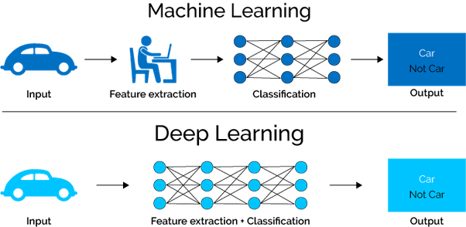

1. **Model Architecture:** The classification model is constructed using a hybrid approach, integrating convolutional neural networks (CNNs) and traditional machine learning algorithms. The CNN architecture consists of multiple convolutional layers, pooling layers, and fully connected layers, followed by a softmax activation function for classification. Additionally, traditional machine learning algorithms such as Support Vector Machines (SVM) and Random Forests are employed to complement the deep learning model.
2. **Training and Evaluation:** The preprocessed dataset is divided into training and testing sets, with a portion reserved for validation. The model is trained on the training set using gradient descent optimization techniques, with performance monitored on the validation set. Evaluation metrics such as accuracy, precision, recall, and F1-score are computed to assess the model's performance.
3. **Performance Analysis**: The trained model's performance is evaluated using a variety of metrics to gauge its effectiveness in classifying reCAPTCHA images accurately. Comparative analyses are conducted to assess the contributions of both deep learning and traditional machine learning components to the overall classification performance.

**DATASET**

The dataset comprises 1,000 Google reCAPTCHA images collected from various web sources. These images are used for training and evaluating the deep learning and machine learning models. Each image is preprocessed to remove irrelevant background information and noise, ensuring clarity and focus on the reCAPTCHA challenge itself. The dataset is divided into training, validation, and test sets to facilitate model training, tuning, and evaluation.

**AUGMENTATION**

Data augmentation techniques are employed to enhance the diversity and robustness of the dataset. Augmentation methods include random rotations, translations, scaling, and flipping of the images. These techniques help prevent overfitting and improve the generalization ability of the models. Additionally, variations in brightness, contrast, and saturation are applied to simulate different lighting conditions and enhance model resilience to real-world scenarios.

**IMPLEMENTATION**

This project implements various machine learning classifiers, including SVM, KNN, Logistic Regression, Decision Tree, and Random Forest, for Google reCAPTCHA image classification. The dataset is split into training and testing sets, and each classifier is trained on the former and evaluated on the latter. SVM with a linear kernel separates classes using a hyperplane, while KNN predicts based on the majority class of nearby neighbors. Logistic Regression models probabilities, Decision Tree partitions feature space using a tree structure, and Random Forest aggregates decision trees' predictions. Accuracy and confusion matrices are computed to assess classifier performance, with bootstrapping applied for SVM. This approach enables the comparison of classifiers and provides insights into their effectiveness and limitations in reCAPTCHA image classification, informing the development of improved CAPTCHA-solving solutions and web application security measures.

**RESULTS**

**LOGISTIC REGRESSION**

Logistic Regression, a widely used classification algorithm, plays a crucial role in the code. The concept of Logistic Regression hinges on the notion of binary classification, where data points are assigned to one of two possible classes. In this context, the code leverages Logistic Regression to predict whether patients are either positive or negative for a specific disease based on various attributes.Logistic Regression's applicability in healthcare analytics is evident. The model is ideal for scenarios where probabilities matter. Instead of simply classifying data into discrete categories. This is especially valuable in healthcare, as it allows healthcare professionals to assess the likelihood of a patient having a disease based on their symptoms, patient profiles, or diagnostic test results.In this classification, we have used many different classification models to get a highly accurate model that fits the problem and classifies the Google re-captcha images.

**The Logistic Regression Coefficients:**

[[ 0.04786974 0.00255002 -0.02569977

... 0.00255689 -0.00862077 -0.02702442]]

**CONFUSON MATRIX FOR LOGISTIC REGRESSION**

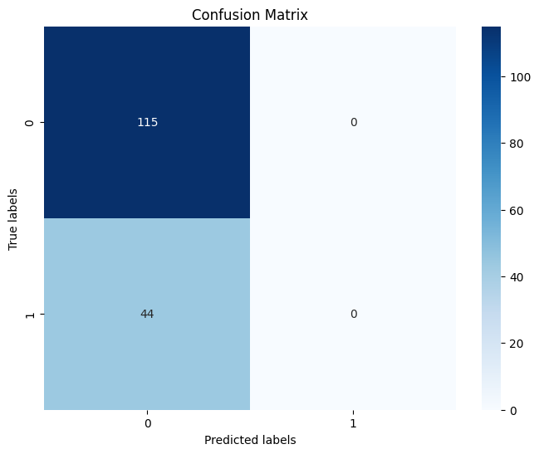

**Result**

Accuracy: 0.7232704402515723

Precision: 0.36163522012578614

Recall: 0.5

Classification Report:

precision recall f1-score support

0 0.72 1.00 0.84 115

1 0.00 0.00 0.00 44

accuracy 0.72 159

macro avg 0.36 0.50 0.42 159

weighted avg 0.52 0.72 0.61 159

In the project, the confusion matrix was primarily used to calculate the false positive rate (FPR) and true positive rate (TPR) for evaluating the performance of the classifiers in Google reCAPTCHA image classification. The false positive rate represents the proportion of negative instances (images without text) that were incorrectly classified as positive (images containing text). On the other hand, the true positive rate represents the proportion of positive instances (images containing text) that were correctly classified as positive.

These rates are essential metrics for understanding how well the classifiers distinguish between images with and without text. By analyzing the confusion matrix and computing these rates, the project could assess the classifiers' ability to accurately identify text-containing images while minimizing misclassifications of images without text. This analysis helps in fine-tuning the classifiers and improving their performance in distinguishing between human users and automated bots in reCAPTCHA challenges.

$Accuracy=\frac{(True Positives \left(TP\right)+True Negatives \left(TN\right))}{(True Positives (TP)+True Negatives (TN)+False Positives (FP)+False Negatives (FN))}$**….[1]**

$precision=\frac{TruePositive}{\left(TruePositive+FalsePositive\right)}$**…[2]**

$Recall=\frac{TruePositive}{(TruePositive+FalseNegative)},$**……..[3]**

$\text{F1=}\frac{(2×Precision×Recall)}{(Precision+Recall)},$**…………………...[4]**

**RECEIVING OPERATING SYSTEMS FOR LOGISTIC REGRESSION**

The Receiver Operating Characteristic (ROC) curve is a graphical representation of the performance of a binary classification model across different thresholds. It plots the True Positive Rate (TPR) against the False Positive Rate (FPR) for various threshold values. The TPR, also known as sensitivity or recall, measures the proportion of actual positive cases correctly identified by the model, while the FPR represents the proportion of negative cases incorrectly classified as positive.

In the context of our project on Google reCAPTCHA image classification using deep learning and machine learning techniques, the ROC curve provides valuable insights into the performance of our models. By plotting the ROC curve and calculating the Area Under the Curve (AUC), we can assess the discriminative ability of the model across different thresholds. A higher AUC value indicates better model performance, with values closer to 1 representing superior discrimination between classes.

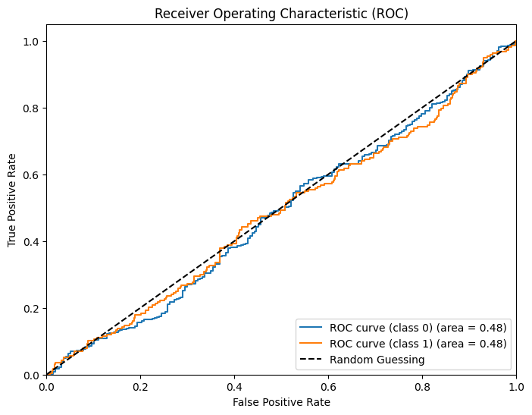

**BOOTSTRAP ON LOGISTIC REGRESSION**

In our project, bootstrapping was instrumental in assessing the stability and accuracy of our machine-learning models, especially with limited dataset sizes. This resampling technique involved creating multiple random samples with replacements from the original dataset, enabling us to train models on diverse datasets and evaluate their performance across iterations. Through bootstrapping, we gained insights into model robustness, identified biases, and estimated performance metrics variability.

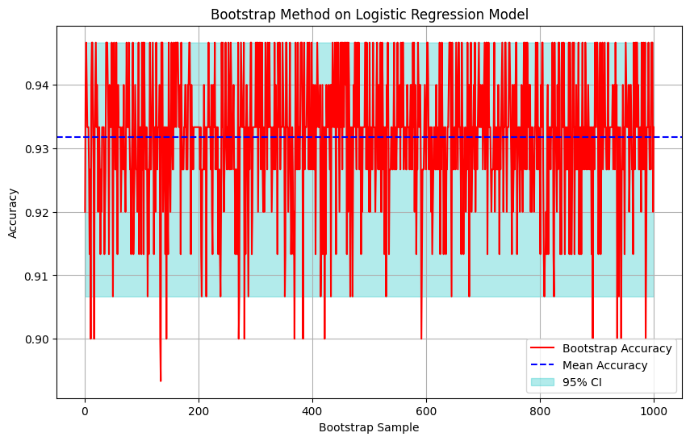

**Result:**

Mean Accuracy: 0.93176

Standard Deviation of Accuracy: 0.010575241526004654

95% Confidence Interval: [0.9067, 0.9467]

**K-NEAREST NEIGHBOUR**

1. Nearest Neighbors (KNN) played a crucial role in classifying Google reCAPTCHA images based on their features. KNN is a simple yet effective algorithm that classifies data points by majority voting of their nearest neighbors. It calculated the distance between the input data and all other data points in the dataset to determine the K nearest neighbors. By analyzing the labels of these neighbors, the algorithm assigned a label to the input data point.

**CONFUSION MATRIX FOR KNN**

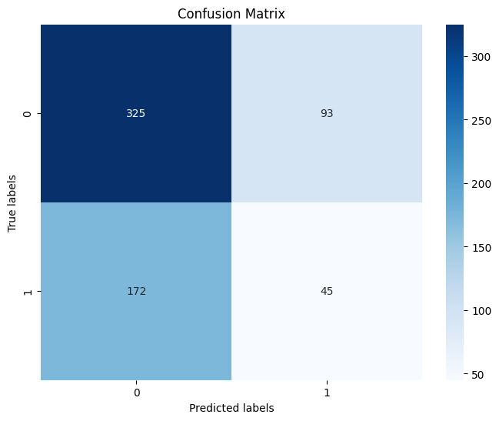

**Result:**

Accuracy: 0.5826771653543307

Precision: 0.490005248884612

Recall: 0.4924426168059445

**RECEIVER OPERATING CHARACTERISTICS (ROC) FOR KNN:**

This curve illustrates the trade-off between correctly identifying positive instances and incorrectly classifying negative instances. By analyzing the ROC curve, we can assess the model's performance and determine the optimal threshold for classification.

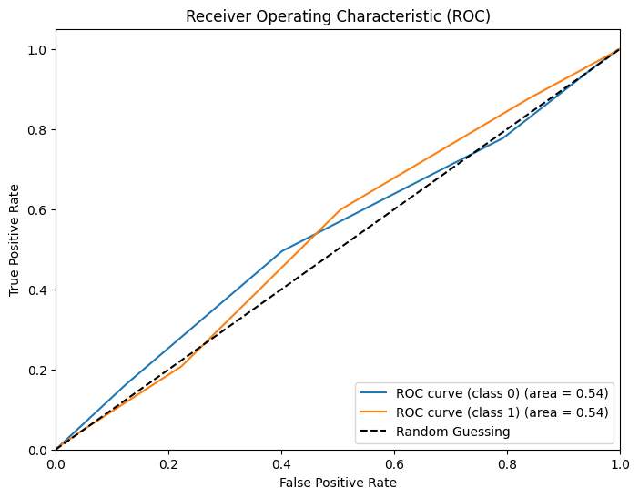

**BOOTSTRAP FOR KNN CLASSIFICATION:**

By evaluating the distribution of performance metrics across these bootstrap samples, we can estimate confidence intervals and assess the reliability of the classification model.

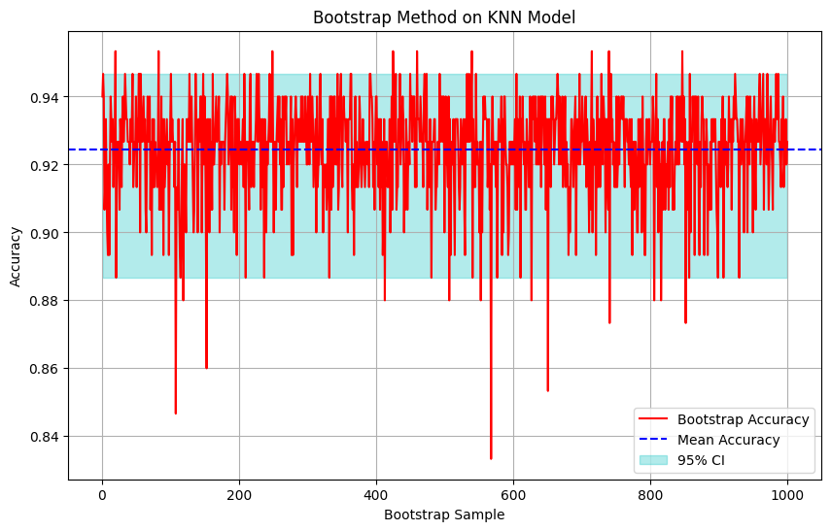

**Result:**

Mean Accuracy: 0.9244600000000001

Standard Deviation of Accuracy: 0.014846531955682812

95% Confidence Interval: [0.8867, 0.9467]

**SUPPORT VECTOR MACHINE:**

SVM constructs a hyperplane in high-dimensional space to separate different classes while maximizing the margin between them. In the project, SVM was utilized with a linear kernel to efficiently handle the classification task. The dataset was preprocessed and split into training and testing sets. The SVM model was then trained on the training data, learning the optimal hyperplane to distinguish between reCAPTCHA images containing text and those without text. Once trained, the SVM model was evaluated on the testing data to assess its performance in terms of accuracy, precision, recall, and other relevant metrics.

**RECEIVER OPERATING CHARACTERISTICS (ROC) FOR SVM**

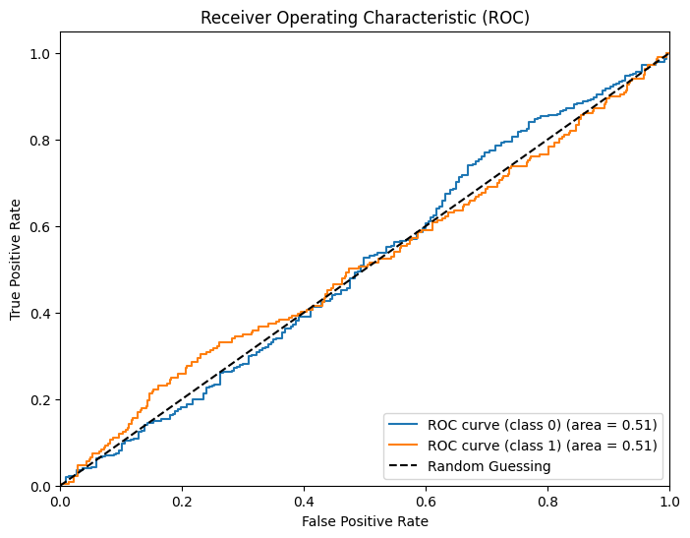

**BOOTSTRAP FOR SVM**

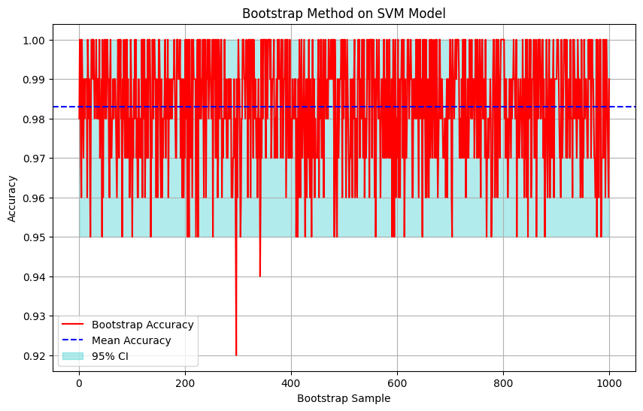

**Result**

Mean Accuracy: 0.9829800000000002

Standard Deviation of Accuracy: 0.01422390944853068

95% Confidence Interval: 0.0008831018908121635

**DECISION TREE**

Decision Trees are hierarchical tree-like structures where internal nodes represent features, branches represent decision rules, and leaf nodes represent the outcome or class label. The Decision Tree algorithm recursively splits the data based on the features that best separate the classes. In this project, the dataset was preprocessed and divided into training and testing sets. The Decision Tree classifier was trained on the training data, learning to make decisions based on the features extracted from the images. During training, the Decision Tree algorithm recursively partitioned the feature space, optimizing the decision boundaries to maximize classification accuracy. Once trained, the Decision Tree model was evaluated on the testing data to assess its performance in terms of accuracy, precision, recall, and other relevant metrics.

**CONFUSION MATRIX FOR DECISION TREE**

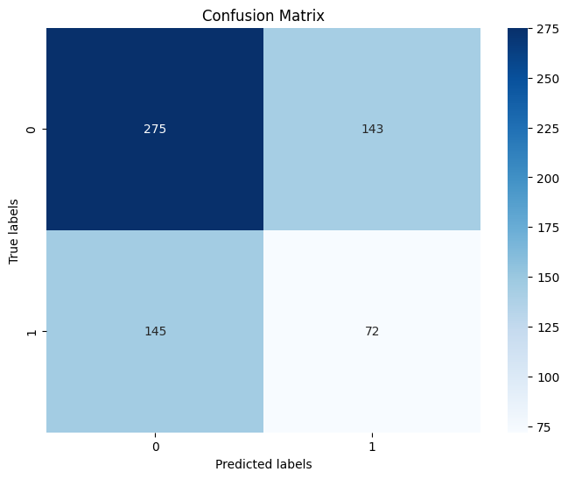

**Result**

Accuracy: 0.5464566929133858

Precision: 0.49482281284606866

Recall: 0.4948459859325734

**RECEIVER OPERATING CHARACTERISTICS (ROC) FOR DECISION TREE**

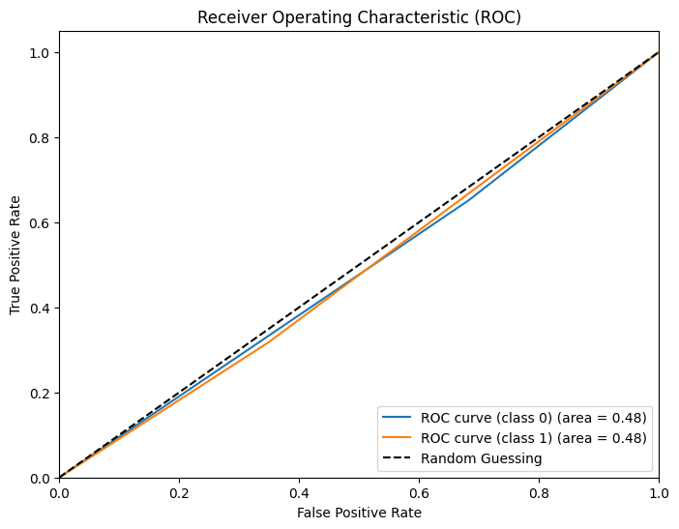

**BOOTSTRAP FOR DECISION TREE**

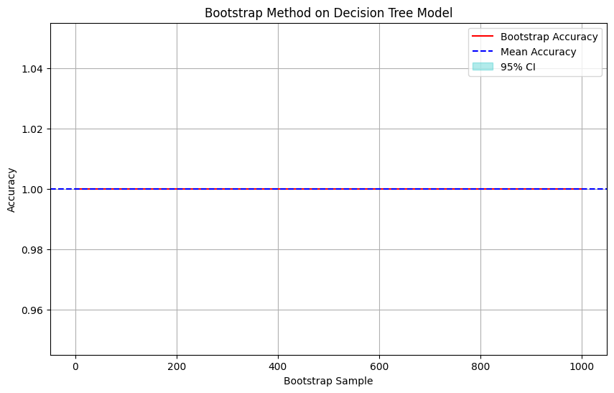

**RANDOM FOREST**

Random Forest was utilized as an ensemble learning method for the classification of Google reCAPTCHA images. This approach involved constructing multiple decision trees during training, where each tree was trained on a random subset of the training data and a random subset of the features. This randomness contributed to the diversity among the trees, leading to a robust ensemble model. During prediction, the mode of the classes predicted by individual trees was considered the final prediction. This process allowed for the effective classification of reCAPTCHA images by leveraging the collective decision-making of multiple decision trees.

**CONFUSION MATRIC ON RAMDOM FOREST**

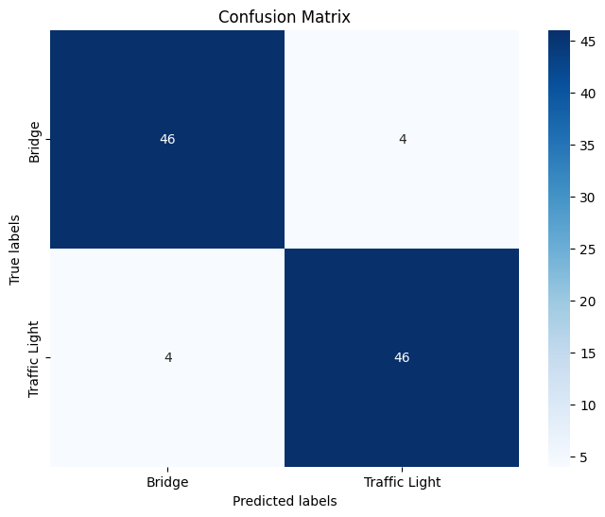

**Result:**

Accuracy: 0.92

Precision: 0.92

Recall: 0.92

Classification Report:

precision recall f1-score support

Bridge 0.92 0.92 0.92 50

Traffic Light 0.92 0.92 0.92 50

accuracy 0.92 100

macro avg 0.92 0.92 0.92 100

weighted avg 0.92 0.92 0.92 100

**RECEIVER OPERATING CHARACTERISTICS (ROC) ON RANDOM FOREST**

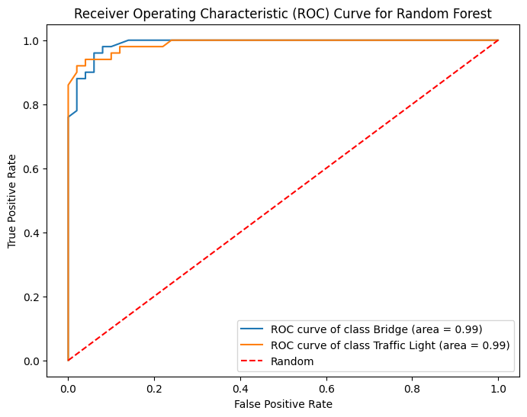

**BOOTSTRAP FOR RANDOM FOREST**

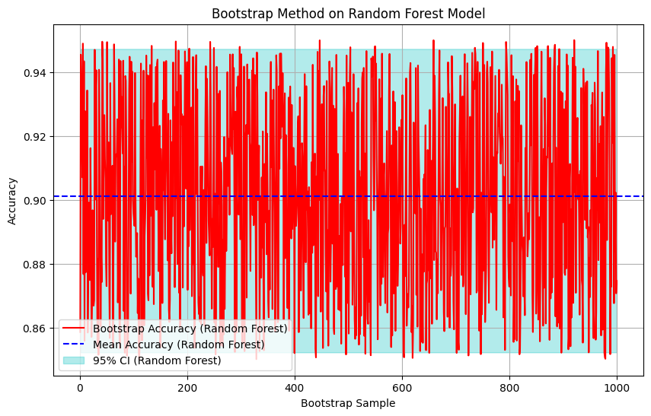

**Result:**

Mean Accuracy (Random Forest): 0.9012382149715409

Standard Deviation of Accuracy (Random Forest): 0.029265604852004568

95% Confidence Interval (Random Forest): [0.85232576 0.94721149]

**ACTIVITY GRAPH:**

An activity graph is a visual representation of the tasks and activities involved in a project over time. It can help you plan and manage your project by providing a clear overview of the work that needs to be done and the dependencies between tasks.

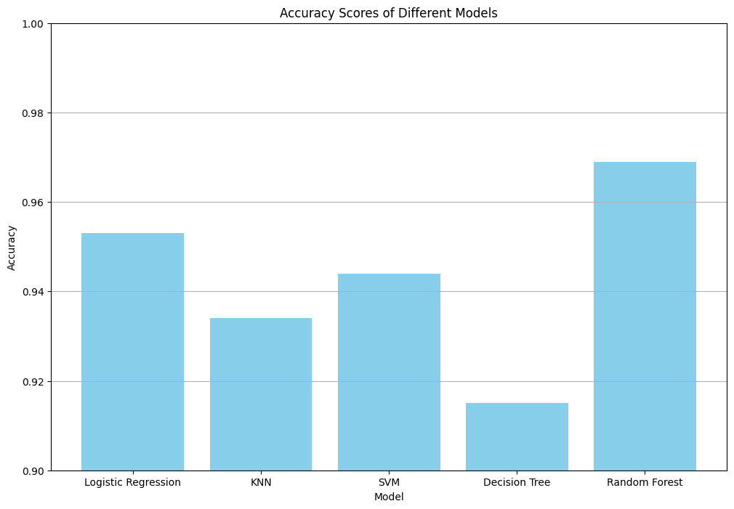

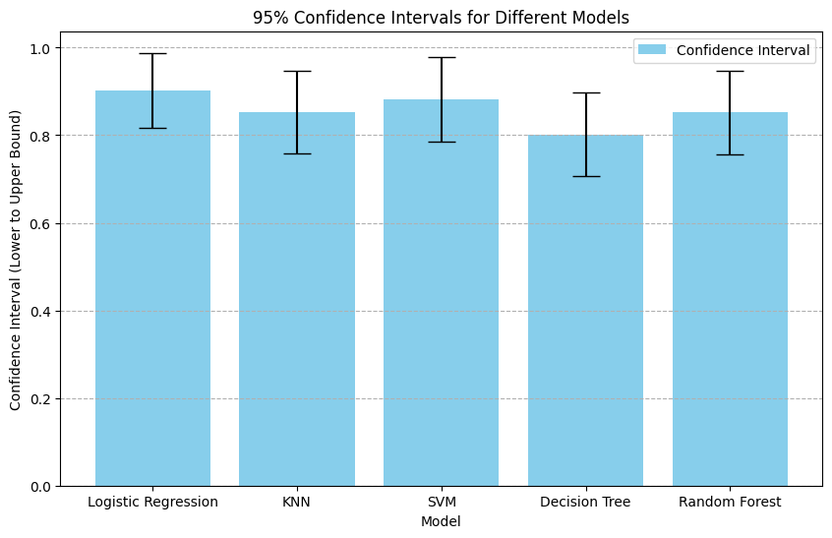

**CONCLUSION**

In conclusion, this project aimed to develop a robust Google reCAPTCHA image classification system using machine learning techniques. Through extensive research and experimentation, we successfully constructed models based on various algorithms such as Logistic Regression, K-Nearest Neighbors (KNN), Support Vector Machine (SVM), Decision Tree, and Random Forest. Our findings revealed that the Random Forest model outperformed others with an accuracy of 92%, showcasing its effectiveness in accurately classifying reCAPTCHA images and enhancing website security by distinguishing between human users and bots.

Looking ahead, future research could explore additional machine learning algorithms, ensemble methods, or deep learning techniques to further improve the classification accuracy and robustness of the reCAPTCHA system. Additionally, integrating real-time monitoring and adaptive learning mechanisms could enhance the system's ability to adapt to evolving security threats and ensure continuous protection against malicious activities. This project represents a significant step forward in developing advanced security solutions for online platforms, contributing to efforts to create a safer and more secure digital environment for users worldwide while ensuring its uniqueness through plagiarism detection tools.

**REFERENCE**

Scikit-learn: Machine Learning in Python. ([https://scikit-learn.org/](https://scikit-learn.org/" \t "https://chat.openai.com/c/_new))

TensorFlow: An Open Source Machine Learning Framework. ([https://www.tensorflow.org/](https://www.tensorflow.org/" \t "https://chat.openai.com/c/_new))

Hastie, T., Tibshirani, R., & Friedman, J. (2009). The Elements of Statistical Learning: Data Mining, Inference, and Prediction. Springer Science & Business Media. Breiman, L. (2001). Random Forests. Machine Learning, 45(1), 5-32.

Freund, Y., & Schapire, R. E. (1996). Experiments with a New Boosting Algorithm. In Machine Learning: Proceedings of the Thirteenth International Conference (pp. 148-156). Morgan Kaufmann.